WEEK 6 TASK ONE: 3
Fig 1: Dashboard 3
Fig 2: Add student page 4
Fig 3: Edit student Information 5
Fig 4: Edit and delete student information 6
TASK TWO LIBRARY BOOK MANAGEMENT SYSTEM 7
Fig 1: Dashboard 7
Fig 2: Editing book records 8
Fig 3: Editing and deletion of book records 9
TASK THREE EMPLOYEE RECORD MANAGEMENT SYSTEM 10
Fig 2: Employee registration page 11
Fig 4: Editing employee records 13
WEEK 6 STUDENT REFLECTION 13
WEEK 7 14
TASK ONE: Student Portal Login system 14
Fig 2: User registration 15
Fig 3: log in page 16
TASK TWO EMPLOYEE SYSTEM 17
Fig 2: Employee registration page 18
Fig 3: Employee login page 19
Fig 4: Editing employee records 20
TASK THREE MULTI USER AUTHENTICATION SYSTEM 21
Fig 1: Dashoard page 21
Fig 2: User registration 22
Fig 3 : Student Dashboard 23
Fig 4: Lecturer Dashboard 24
Fig 5: Amin dashboard 25
WEEK 7 STUDENT REFLECTION 25

WEEK 6 & 7 LOGBOOK

WEEK 6 TASK ONE:
Student Management System
Develop a mini Student Management System that can:

Fig 1: Dashboard
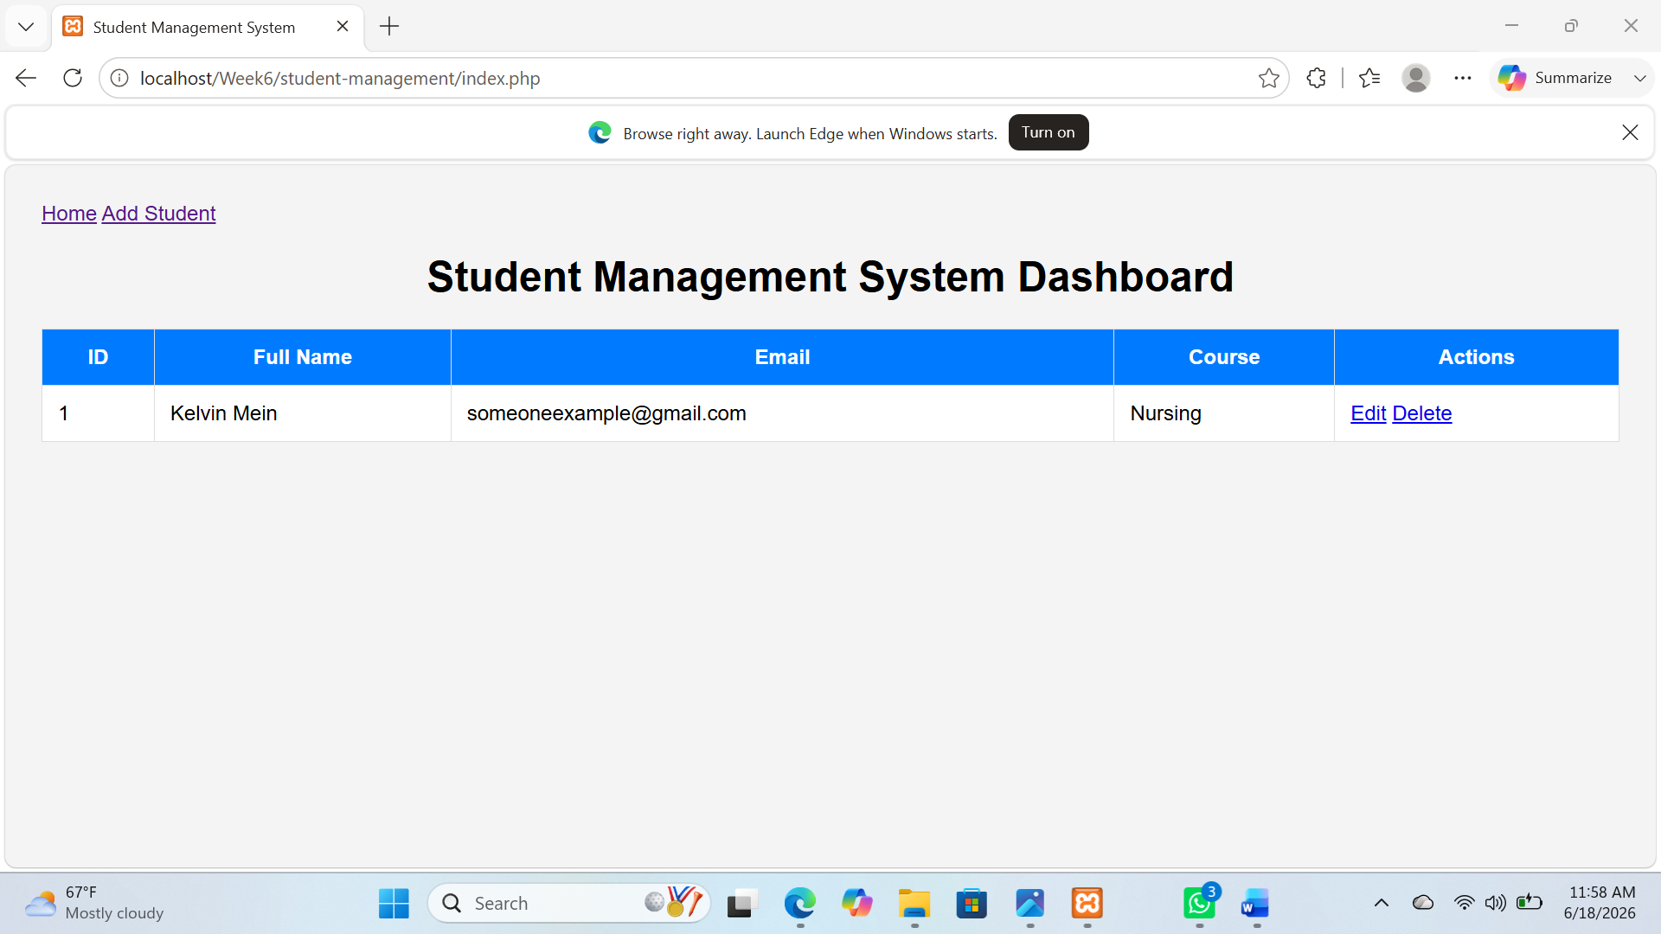

Fig 2: Add student page
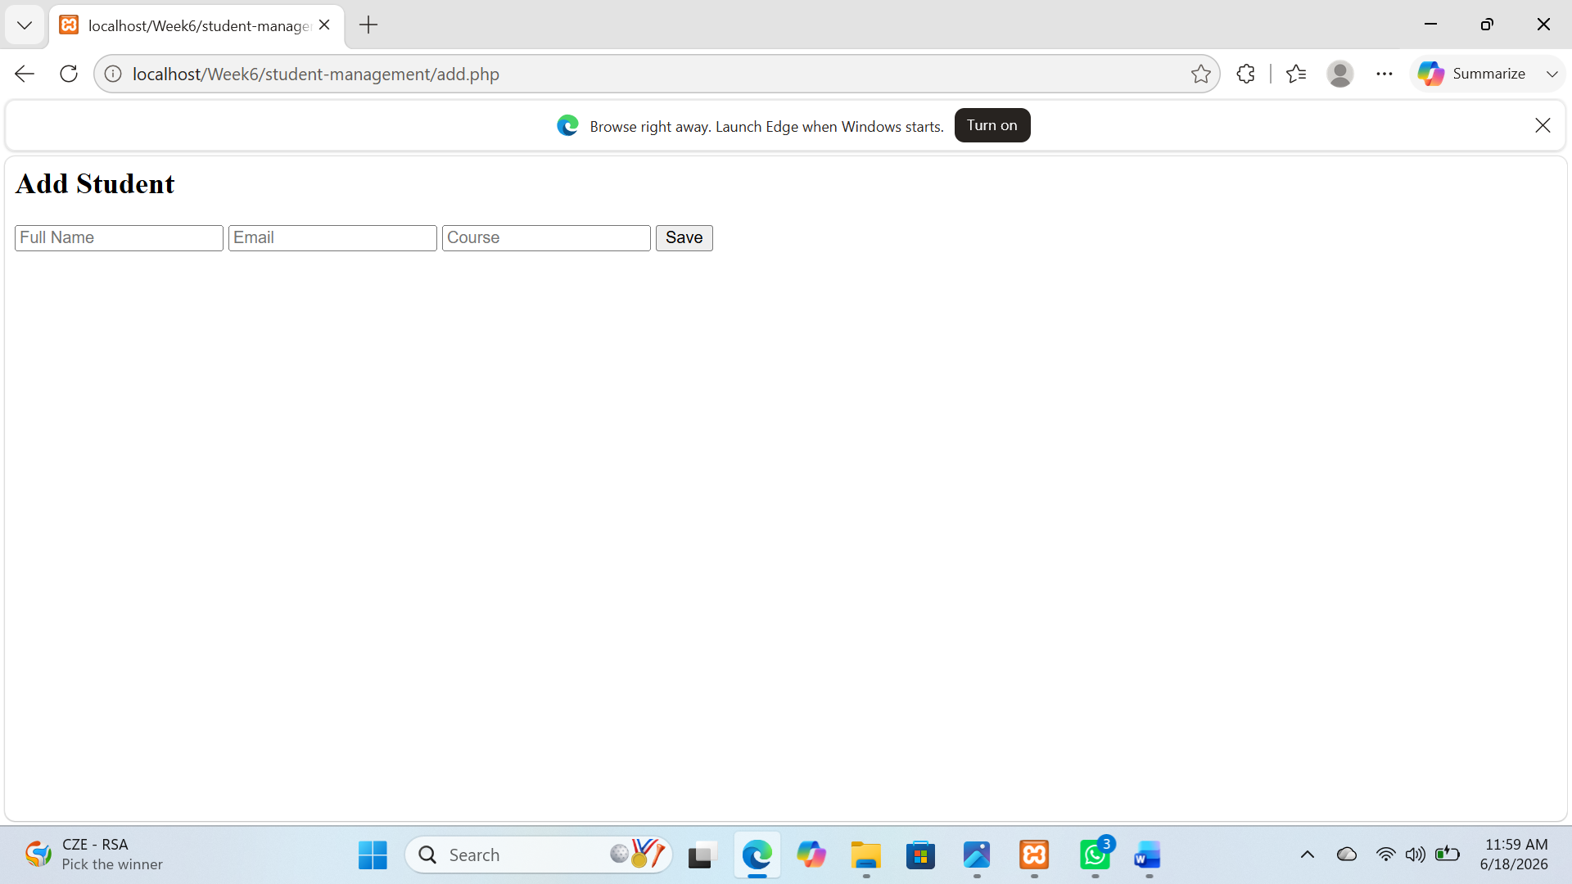

Fig 3: Edit student Information
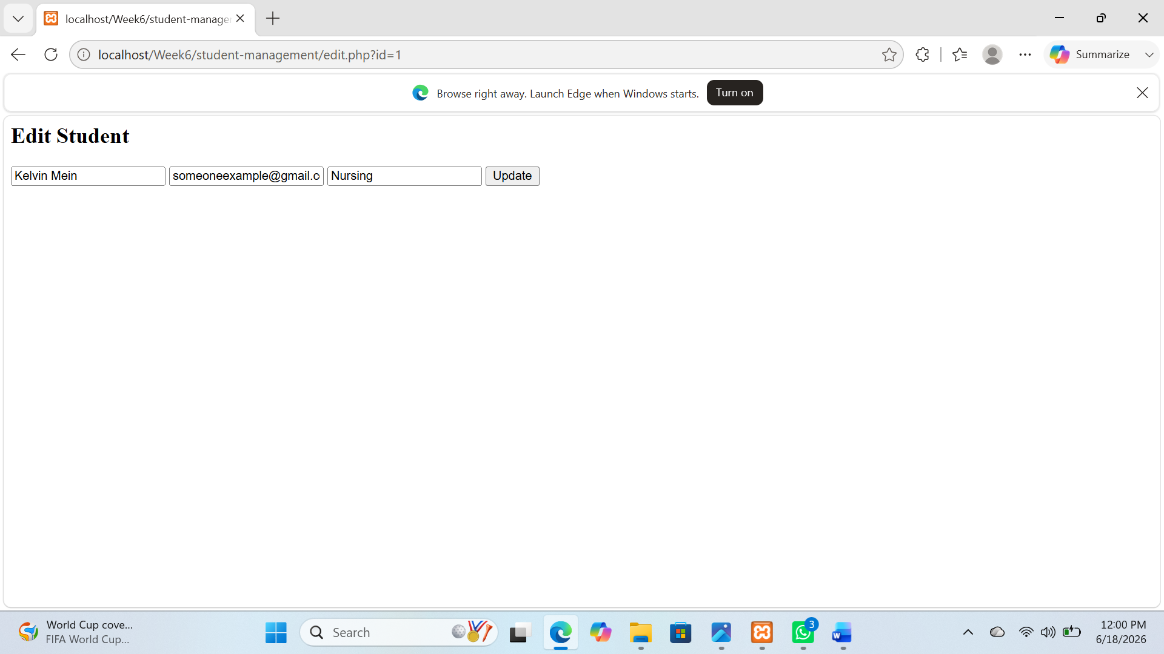

Fig 4: Edit and delete student information


TASK TWO LIBRARY BOOK MANAGEMENT SYSTEM

Fig 1: Dashboard
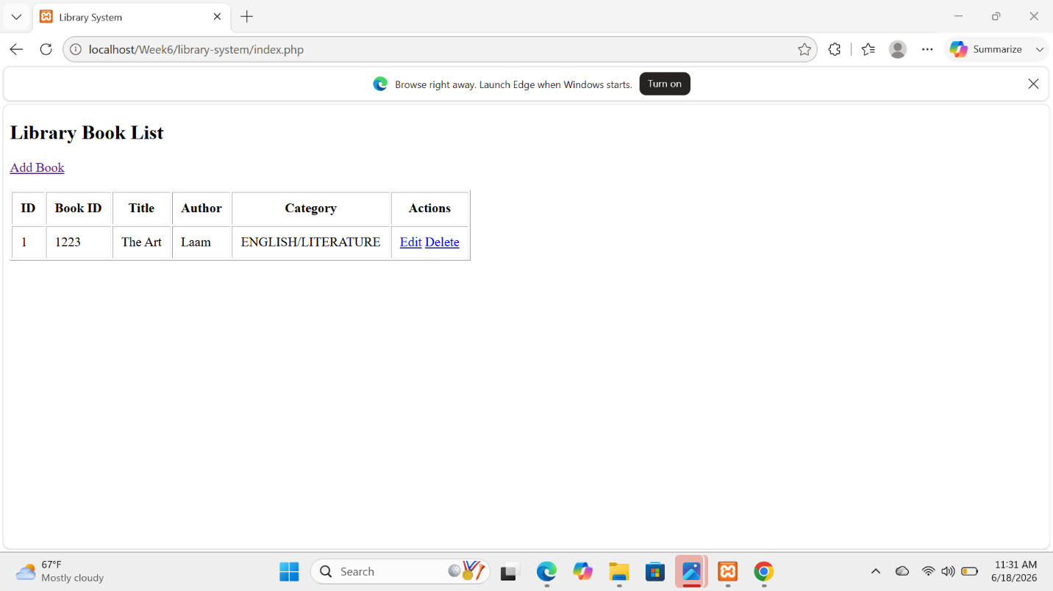

Fig 2: Editing book records
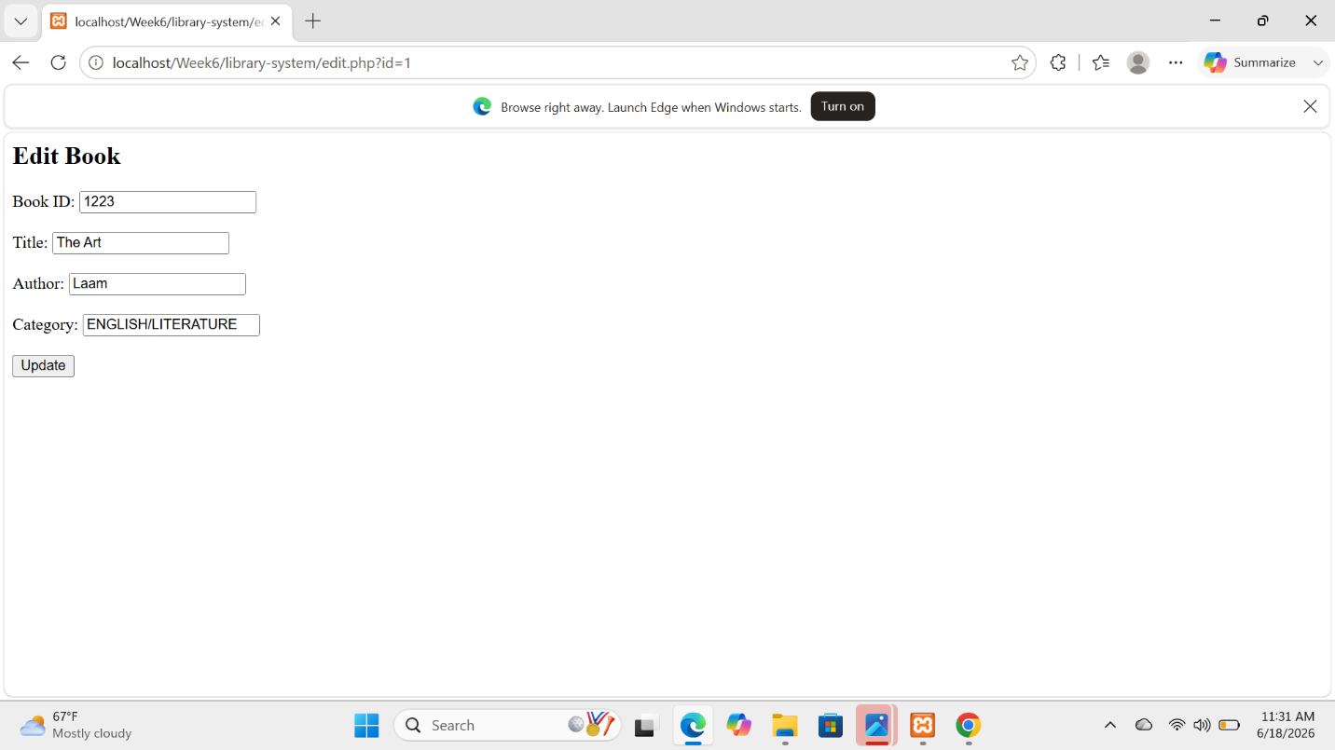

Fig 3: Editing and deletion of book records


TASK THREE EMPLOYEE RECORD MANAGEMENT SYSTEM

Fig 1: Dashboard
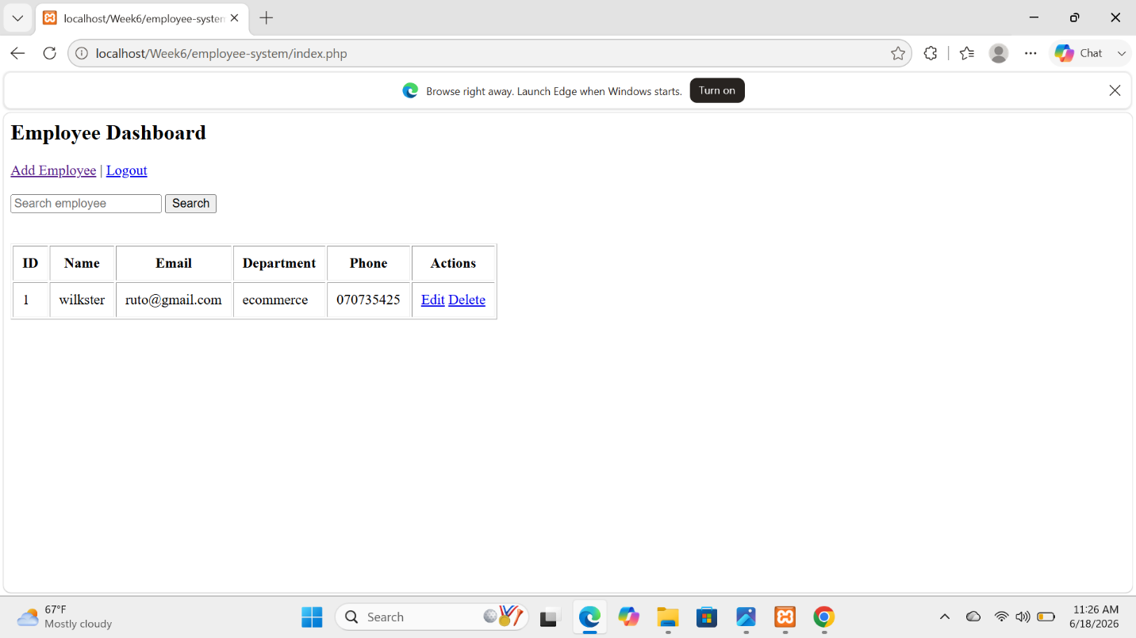

Fig 2: Employee registration page
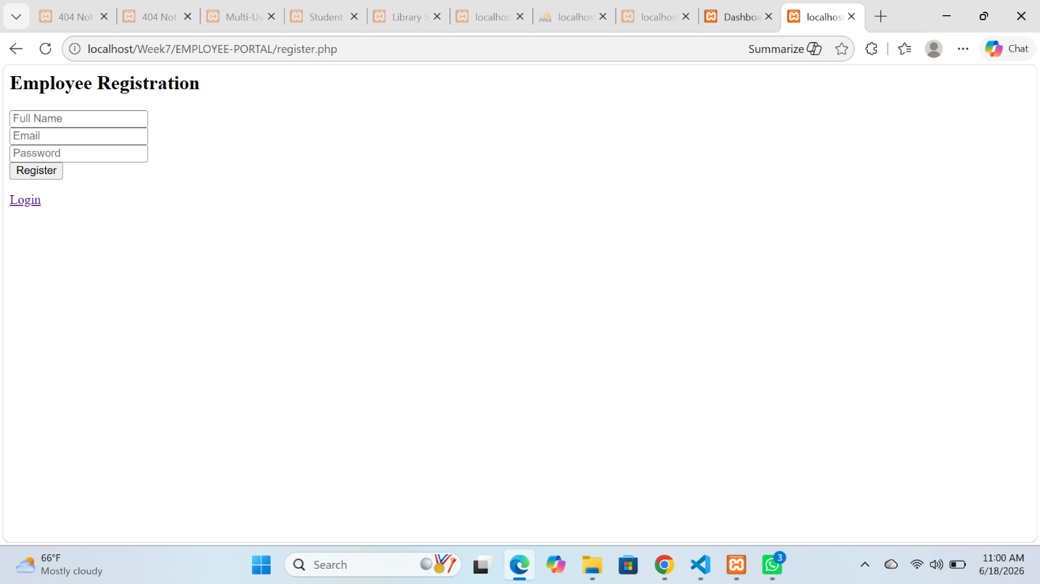

Fig 3: Employee login page
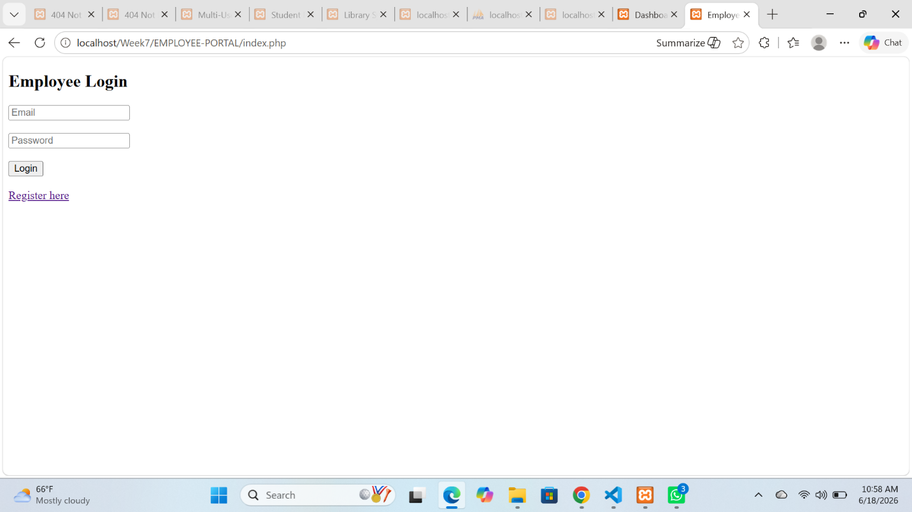

Fig 4: Editing employee records
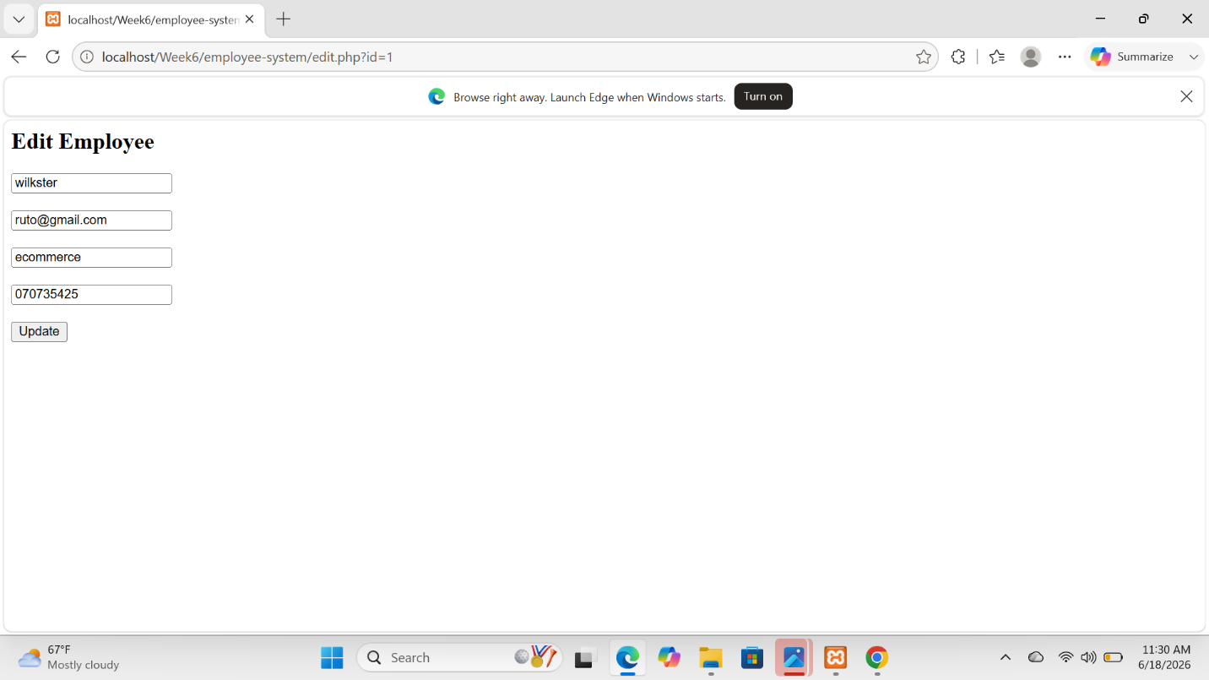

WEEK 6 STUDENT REFLECTION
This practical work enhanced my skills in building CRUD-based web applications using databases. I learned how to implement add, view, update, and delete operations for student, book, and employee records. It also improved my understanding of database integration, form handling, and user interface design. The tasks strengthened my ability to develop structured and functional management systems.

WEEK 7

TASK ONE: Student Portal Login system
Fig 1: Dashboard
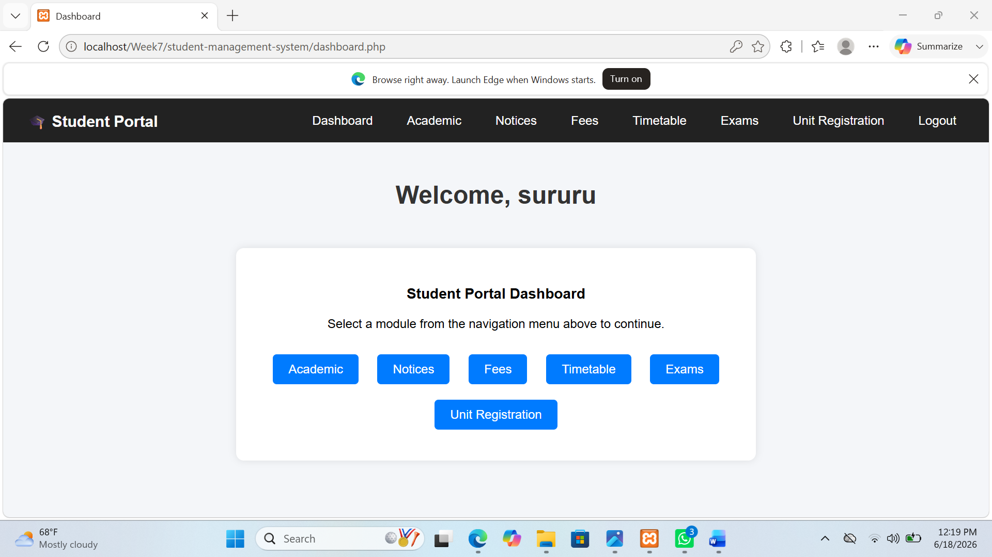

Fig 2: User registration
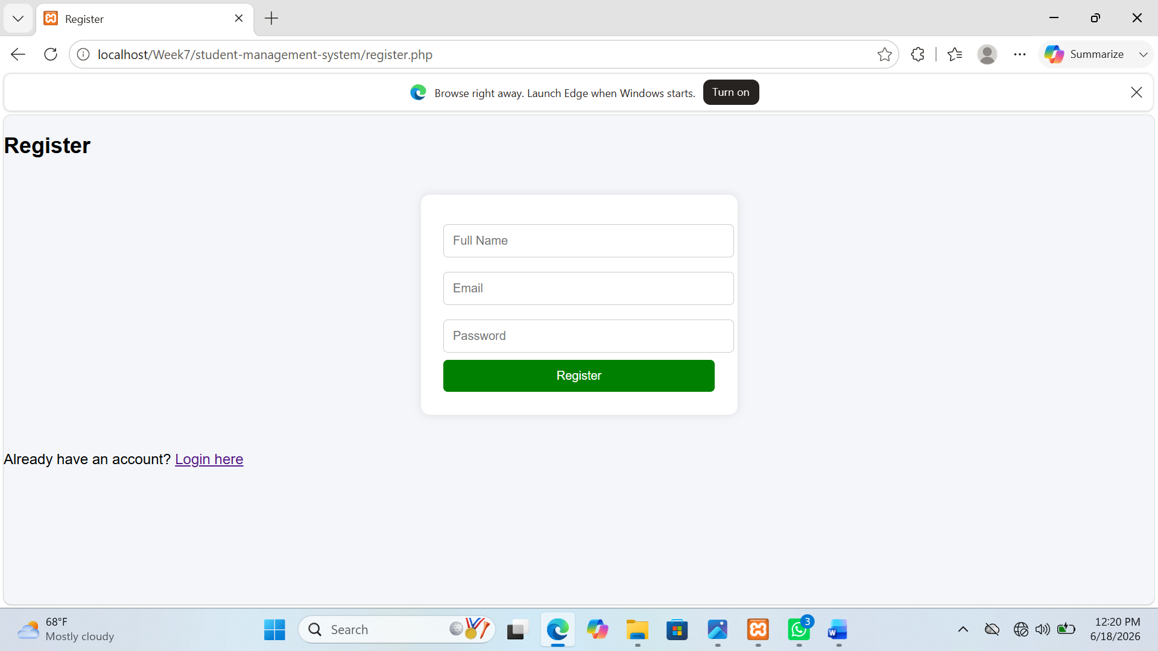

Fig 3: log in page
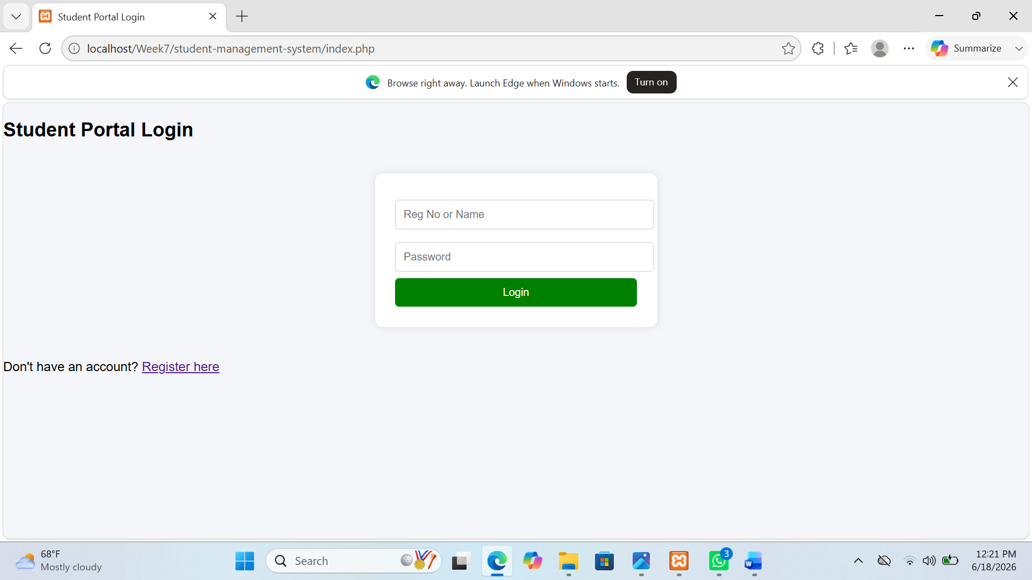

TASK TWO EMPLOYEE SYSTEM

Fig 1: Dashboard


Fig 2: Employee registration page


Fig 3: Employee login page


Fig 4: Editing employee records


TASK THREE MULTI USER AUTHENTICATION SYSTEM

Fig 1: Dashoard page
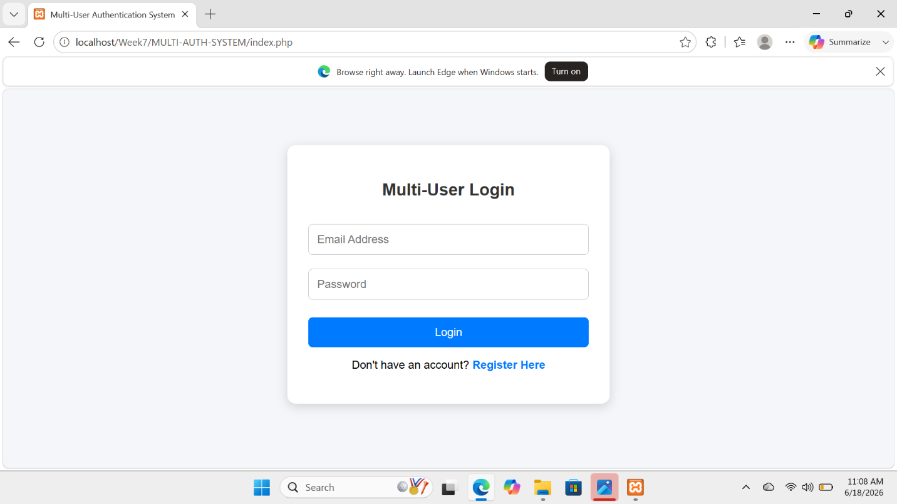

Fig 2: User registration
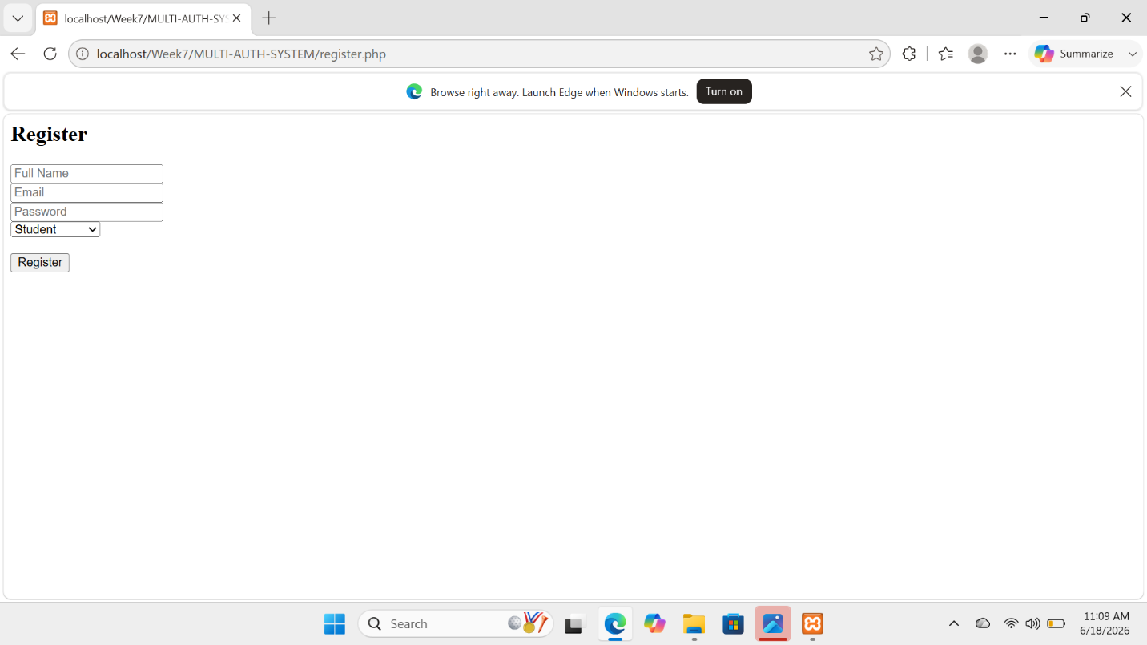

Fig 3 : Student Dashboard
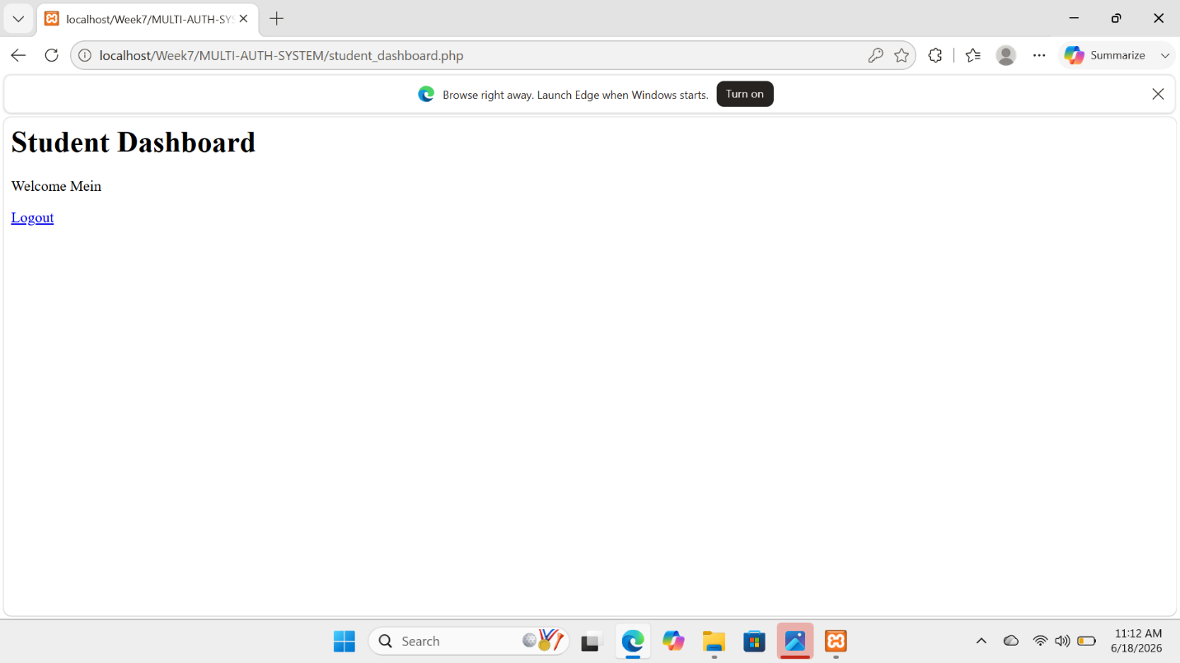

Fig 4: Lecturer Dashboard
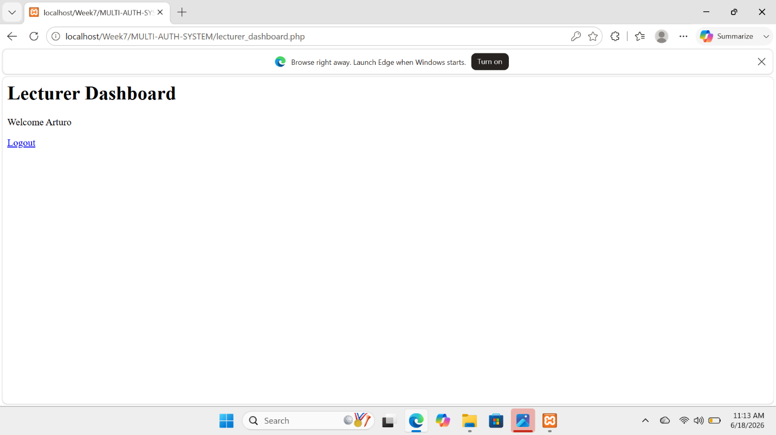

Fig 5: Amin dashboard
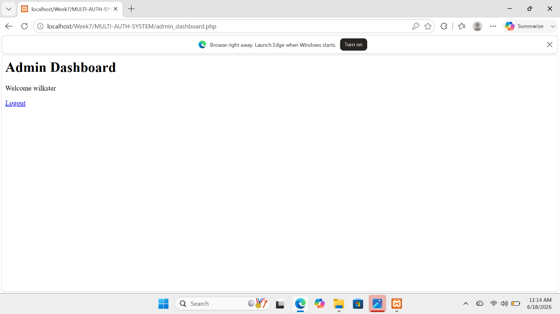

WEEK 7 STUDENT REFLECTION
This practical work improved my understanding of web authentication systems and session management. I learned how to implement user registration, login, and logout functionalities, as well as protect pages using sessions. The tasks also strengthened my skills in building role-based access systems for students, employees, and administrators, and applying access restrictions across different dashboards effective

